**Network Task**

**Task Description:**

1.Get me the IP address of a particular domain (guvi.in). How do I find my CPU/memory usage of my server?. Test the connectivity between 2 nodes?

**Output**:-

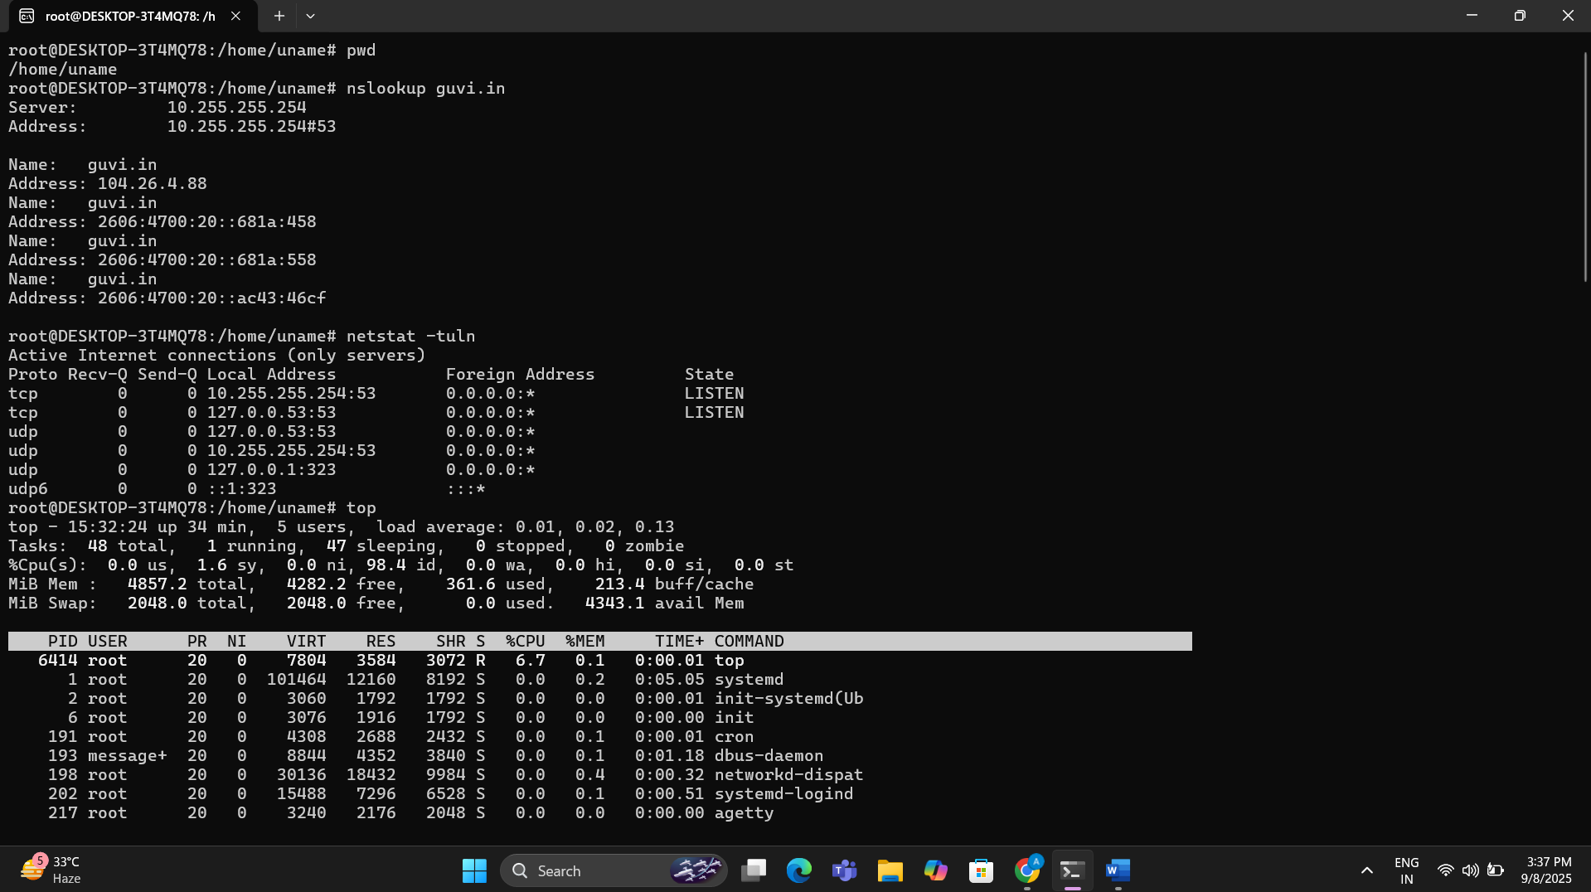

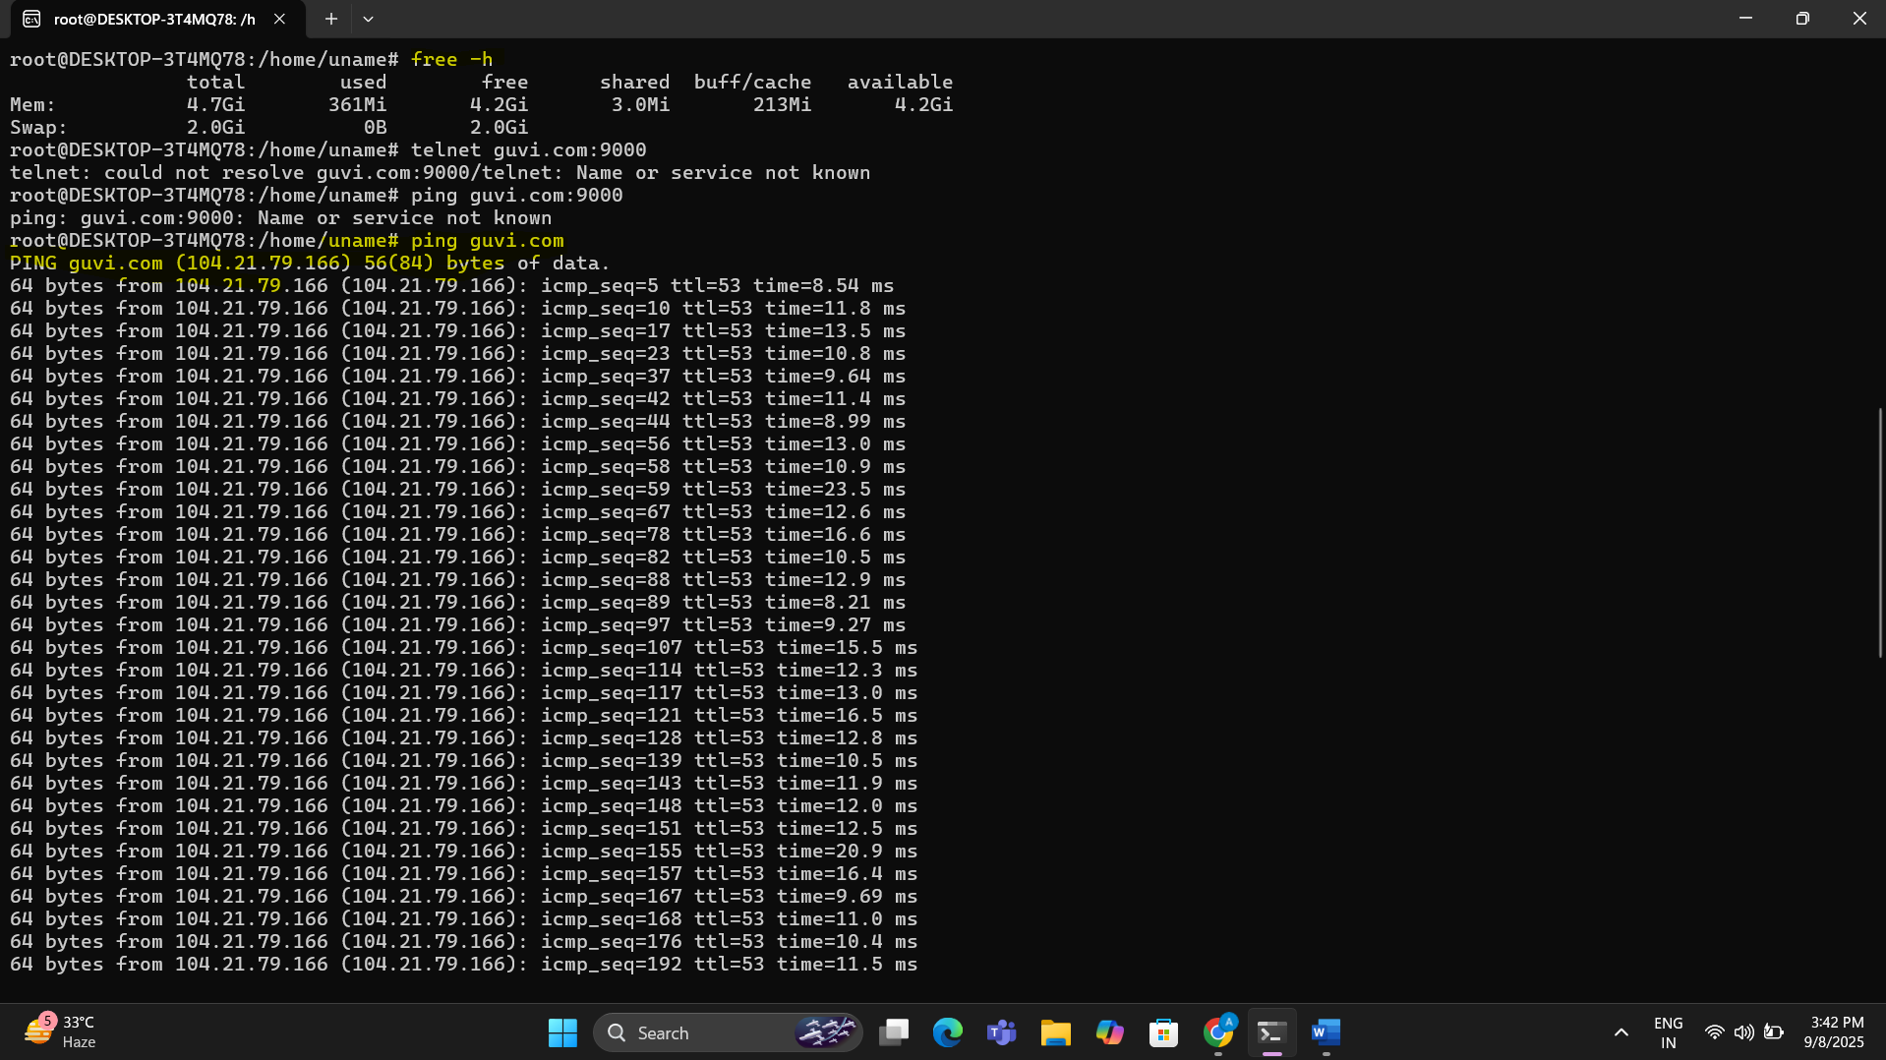

2.I have deployed an application in guvi.com:9000, and logs show my app is running, but I’m unable to view the page. Check whether my port is open or not ?

**Output**:-

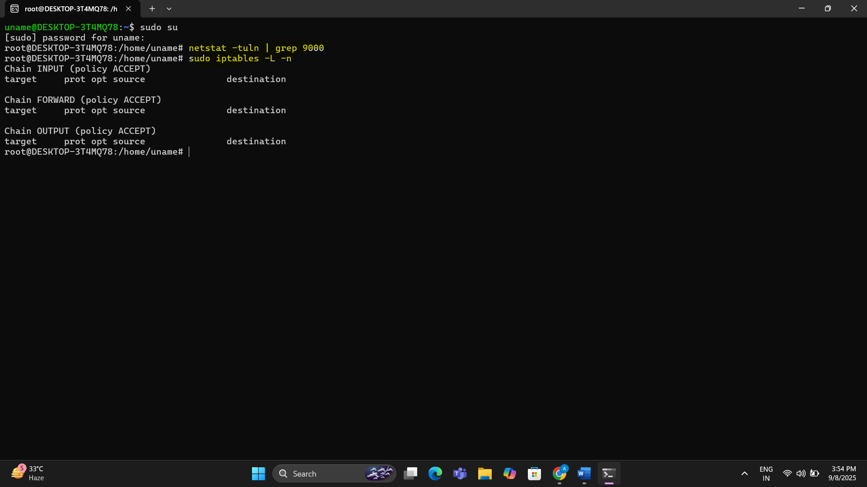

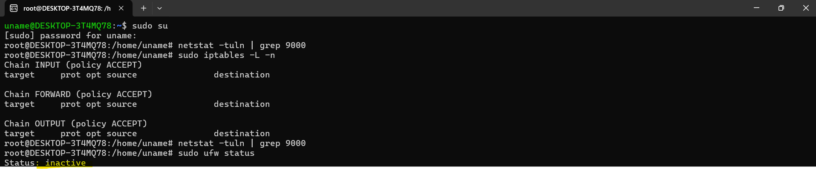

**Techstacks needs to be used :**

* Shell (AWS, Gitbash, WSL, Vbox)

**How do I submit my work?**

* Push all your work files to GitHub (O/P screenshot images must).
* Submit your URLs in the portal.

**Terms and Conditions?**

* You agree to not share this confidential document with anyone.
* You agree to open-source your code (it may even look good on your profile!). Do not mention our company’s name anywhere in the code.
* We will never use your source code under any circumstances for any commercial purposes; this is just a basic assessment task.

**NOTE:** Any violation of Terms and conditions is strictly prohibited. You are bound to adhere to it.